Introduction to Information Communication & Technologies - Lab
BSCS [1-A]

FINAL TERM PROJECT REPORT

Submitted By
Bushra Masood

PROJECT NAME

Linkedin website Frontend

Abstract

Actual meaning of the project topic "Linkedin"
1.linkedin is basically a social linking network which is specifically designed for career and business professionals to connect.
2. It is about building strategic relationships. You can be in friend zone with anyone and everyone.
3. Through it, we can send our content or any other information to the targeted group. The number of times our content was shown to the followers and members of Linkedin company, the more good impression it becomes!
Need of this project
It is great need of today’s society because of the job searching activities, for professional networking and growing of contacts.it is a powerful tool for finding and applying for jobs.
Hypothesis
We used hypertext markup language and cascading style sheets to produce this website page Linkedin. Many types of tags are also used in this making of website like of header, footer, body, head, styles, titles, links and etc. They are written in the coding.

Introduction
Our project is LinkedIn website
LinkedIn is a professional networking site, designed to help people make business connections, share their experiences and resumes, and find jobs. It is a social network that focuses on professional networking and career development. You can use LinkedIn to display your resume, search for jobs, and enhance your professional reputation by posting updates and interacting with other people. LinkedIn is free, but a subscription version called LinkedIn Premium offers additional features like online classes and seminars, as well as insights into who's searching for and viewing your profile. They now have over 660 million people on the platform and that number is still growing which means nearly an unlimited supply of network connections and job opportunities.

LinkedIn is the largest professional network in the world. The site is a great fit for businesses, not only to promote themselves but to establish connections and build relationships. It is one of your most powerful professional tools. With it, you can build and maintain your network, search for jobs, and build your professional reputation. Plus it's free. , A complete LinkedIn profile can help you connect with opportunities by showcasing your unique professional story through experience, skills, and education. You can also use LinkedIn to organize offline events, join groups, write articles, post photos and videos, and more.
Job searches are filled with obstacles and challenges that can drain even the most resilient person’s motivation and this is the reason that motivates us to make this website. The goal of the site is to allow registered members to establish and document networks of people they know and trust professionally .Moreover you can also learn the skills from Linkedin and then find job on Linkedin.
LinkedIn is an important part of being a full-fledged professional in any industry these days. LinkedIn is currently the most important career-oriented social media channel .During the Covid 19 situation this network helps to continue your profession online by seeking suitable job on Linkedin. Thus Linkedin helps a lot in advancement these days.

Website Name
- We choose LinkedIn website because LinkedIn is the world's largest professional network on the internet.
- You can use LinkedIn to find the right job or internship, connect and strengthen professional relationships, and learn the skills you need to succeed in your career.
- LinkedIn is an important part of being a full-fledged professional in any industry these days and because of its great importance we choose this website.

Methodology &Technologies Involved
Html and css is used to implement the project.
Html tags and attributes are used to make project. The css style sheet contains all formatting details of each object in the document.

We used tools like notepad++ and visual studios for this html and css coding.
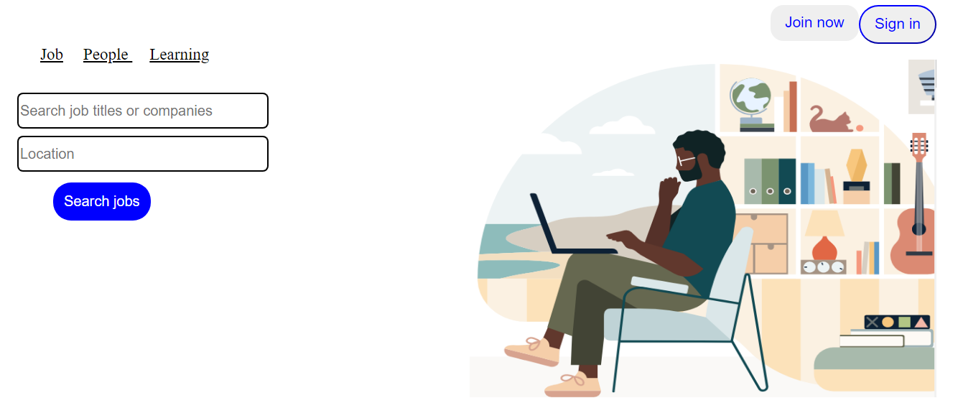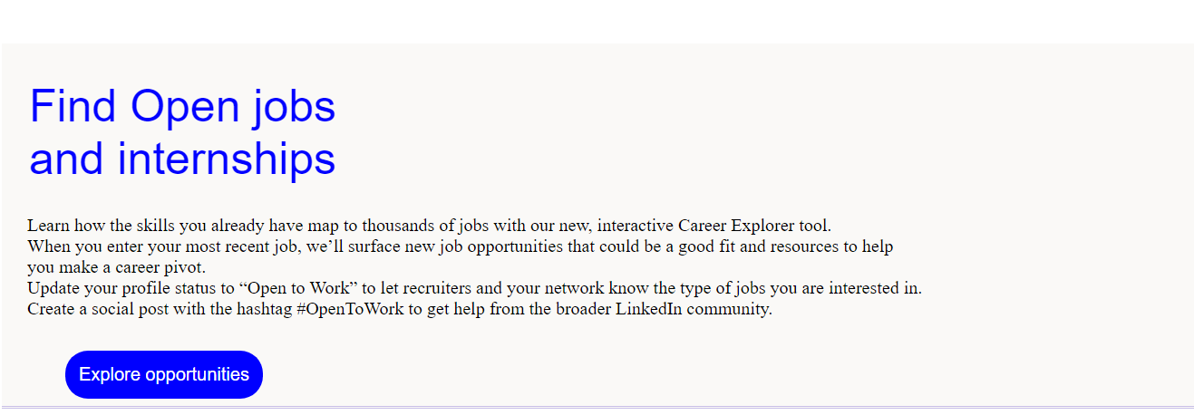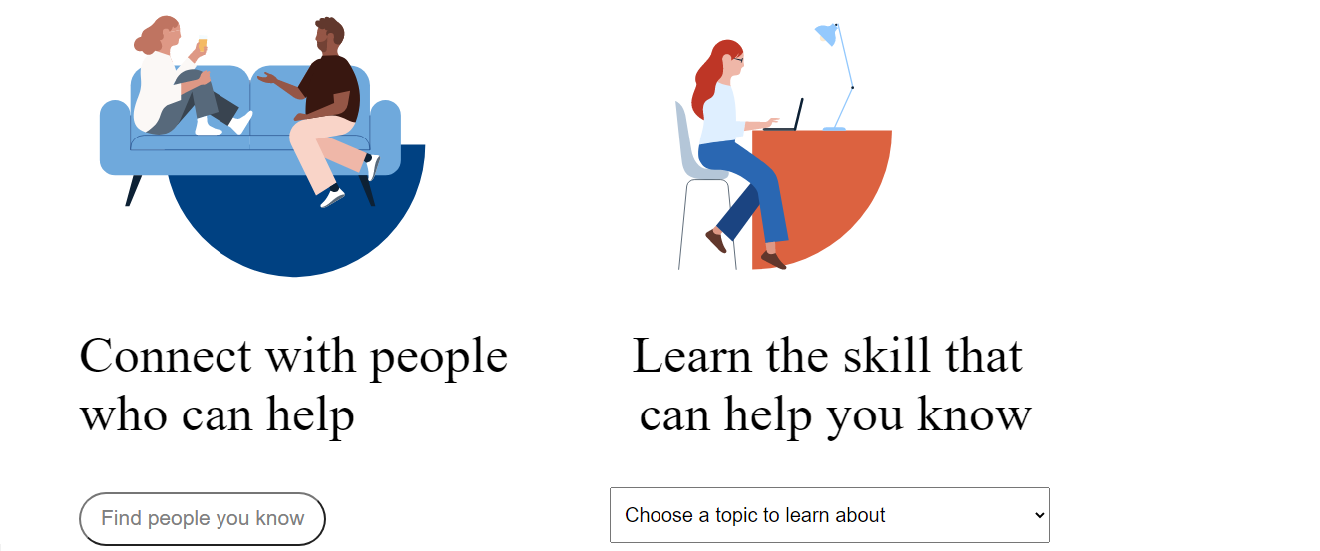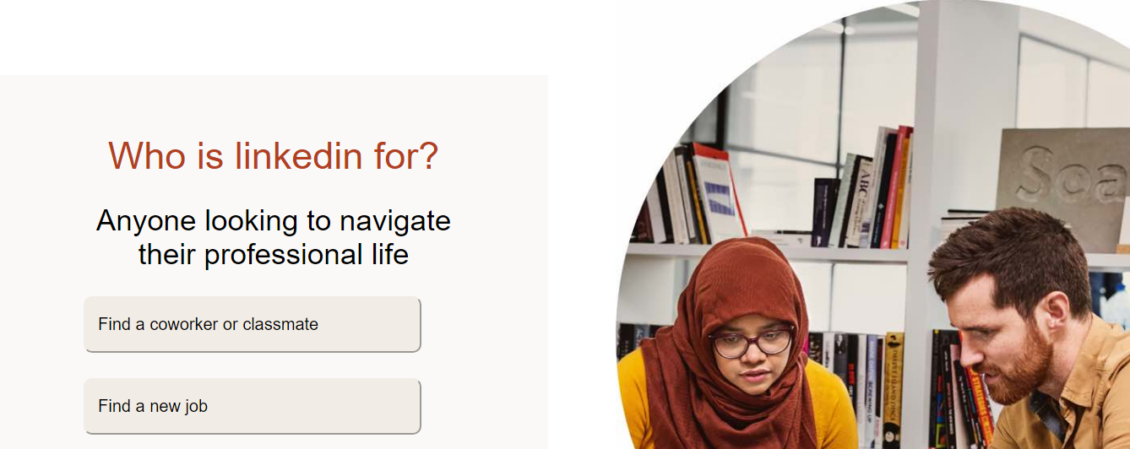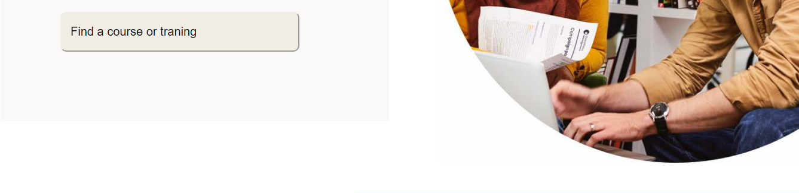

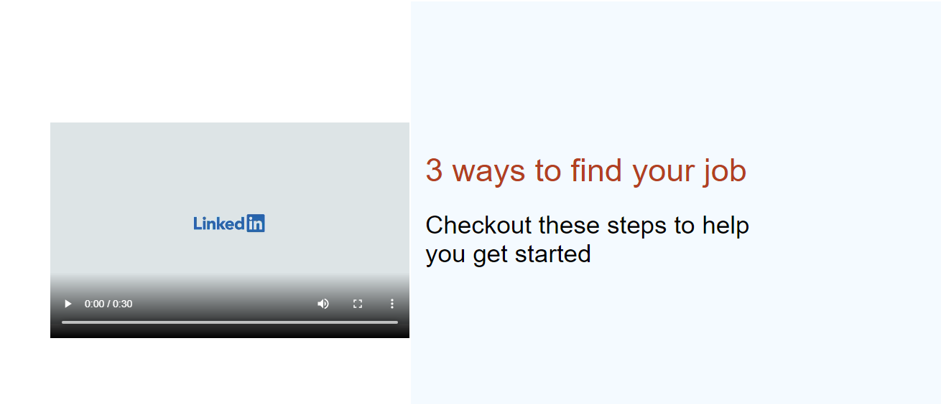
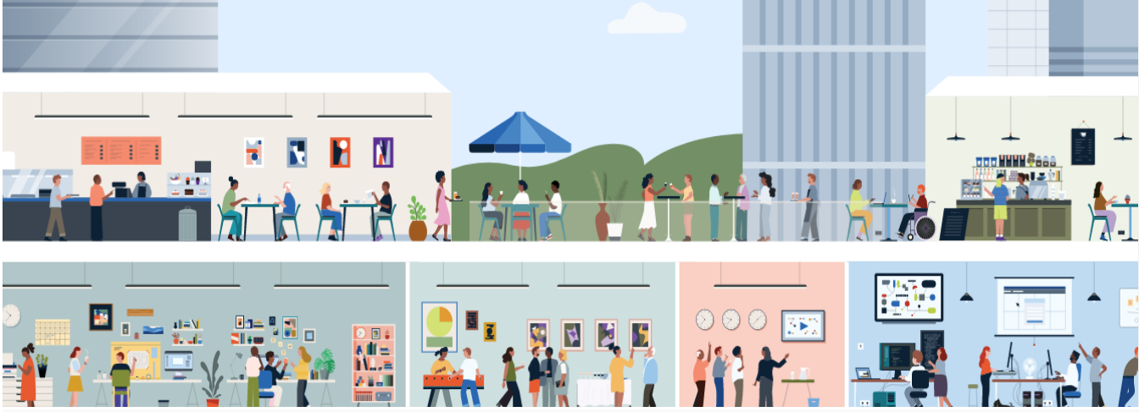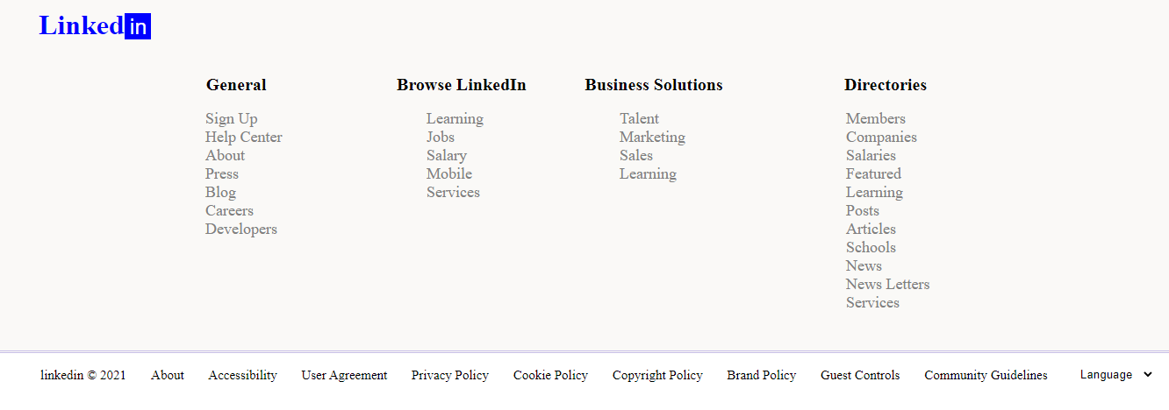

Code
Html code
<html>
<head>
<title>ict website project</title>
<link rel="stylesheet" href="stylesheet.css" />
</head>
<body>
<img class="image-2" src="E:\ict project file\download.png">
<div class=" head">
<h1 class="h3">Linked<button type="submit" class="button">in</button></h1>
<h1 class="h7">Open jobs. People<br />hiring.</h1>
<ul class="header">
<li><button class="butt">Sign in</button></li>
<li><button class="but">Join now</button></li>
</ul>
<img class="image-1" src="E:\ict project file\img3.png">
<ul class="front">
<li><a href="">Job</a></li>
<li><a href=""> People </a></li>
<li><a href="">Learning</a></li>
</ul>
<input class="input" type="text" name="name" placeholder="Search job titles or companies"><br />
<input class="input" type="text" name="name" placeholder="Location" /><br />
<button class="btn-1">Search jobs</button><br />
</div>
<div class="foot">
<h1 class="h7">Find Open jobs<br />and internships</h1>
<p>
Learn how the skills you already have map to thousands of
jobs with our new, interactive Career Explorer tool.<br />
When you enter your most recent job, we’ll surface new job
opportunities that could be a good fit and resources to help<br />
you make a career pivot.<br />
Update your profile status to “Open to Work” to let recruiters and your network know the type of jobs you are interested in.<br />
Create a social post with the hashtag #OpenToWork to get help from the broader LinkedIn community.</p>
<button class="btn-1">Explore opportunities</button><br />
</div>
<img class="img" src="https://static-exp1.licdn.com/sc/h/b1fxwht7hdbeusleja7ciftsj">
<img class="img " src="https://static-exp1.licdn.com/sc/h/dkfub4sc7jgzg3o31flfr91rv">
<h1 class="h">Connect with people</h1>
<h1 class="h">Learn the skill that</h1><br />
<h1 class="h1i">who can help</h1>
<h1 class="h1i"> can help you know</h1>
<button class="btn">Find people you know</button>
<select class="select">
<option value="0">Choose a topic to learn about</option>
<option value="1">Training and Education 290+ courses</option>
<option value="2">IT Help Desk 170+ courses</option>
<option value="3">Business Analysis and Strategy 720+ courses</option>
<option value="4">Finance and Accounting 210+ courses</option>
<option value="5">Career Development 280+ courses</option>
<option value="6">Leadership and Management 1,100+ course</option>
<option value="7">Mobile Development 370+ courses</option>
<option value="8">Marketing 660+ courses</option>
<option value="9">Cloud Computing 530+ courses</option>
<option value="10">Project Management 320+ courses</option>
<option value="12">Project Management 320+ courses</option>
<option value="13">Visualization and Real-Time 770+ courses</option>
<option value="14">Animation and Illustration 1,100+ course</option>
<option value="15">Audio and Music 380+ courses</option>
<option value="16">AEC 1,000+ course</option>
<option value="17">Graphic Design 880+ courses</option>
<option value="18">Motion Graphics and VFX 760+ courses</option>
<option value="19">Database Management 230+ courses</option>
<option value="20">Product and Manufacturing 820+ courses</option>
<option value="21">Human Resources 250+ courses</option>
<option value="22">Photography 950+ courses</option>
<option value="23">Video 710+ courses</option>
<option value="24">Data Science 680+ courses</option>
<option value="25">DevOps 190+ courses</option>
<option value="26">Customer Service 130+ courses</option>
<option value="27">Professional Development 1,000+ course</option>
<option value="28">Business Software and Tools 1,600+ course</option>
<option value="29">Security 380+ courses</option>
</select>
<div class="div">
<div class="leftdiv">
<h1 class="h4">Who is linkedin for?</h1>Anyone looking to navigate<br /> their professional life
<button class="buttn">Find a coworker or classmate</button>
<button class="buttn">Find a new job</button>
<button class="buttn">Find a course or traning</button>
</div>
<img class="image" src="C:\Users\FAST\Documents\292yd0en6qdvkbezeuj71yu4y.jpg"><br />
</div><br />
<div class="div">
<div class="rightdiv"><h1 class="h5">3 ways to find your job</h1><h1 class="h6">Checkout these steps to help<br /> you get started</h1></div>
<video class="video" width="500" height="320" controls>
<source src="E:\ict project file\Three Ways to Find Your Next Job on LinkedIn.mp4">
</video>
</div>
<div class="lastdiv">
<h1 class="h7">Join your colleagues, classmates and<br />friends on linkedin<br /></h1>
<button class="btn-1">Get started</button><br />
<img class="image-3" src="E:\ict project file\ict pic.png"><br />
</div>
<div class="foot">
<h1 class="h3">Linked<button type="submit" class="button">in</button></h1>
<div class="d1">
<h2 class="h2i">General</h2>
<ul class="dd1">
<li><a href="">Sign Up</a></li>
<li><a href="">Help Center </a></li>
<li><a href="">About</a></li>
<li><a href="">Press </a></li>
<li><a href="">Blog </a></li>
<li><a href="">Careers </a></li>
<li><a href=""> Developers </a></li>
</ul>
</div>
<div class="d3">
<h2 class="h2i">Directories</h2>
<ul class="dd3">
<li><a href="">Members</a></li>
<li><a href="">Companies</a></li>
<li><a href="">Salaries</a></li>
<li><a href="">Featured</a></li>
<li><a href="">Learning </a></li>
<li><a href="">Posts</a></li>
<li><a href="">Articles </a></li>
<li><a href="">Schools </a></li>
<li><a href="">News </a></li>
<li><a href="">News Letters </a></li>
<li><a href="">Services </a></li>
</ul>
</div>
<div class="d4">
<h2 class="h2i">Business Solutions</h2>
<ul class="dd4">
<li><a href="">Talent</a></li>
<li><a href="">Marketing </a></li>
<li><a href="">Sales</a></li>
<li><a href="">Learning </a></li>
</ul>
</div>
<div class="d5">
<h2 class="h2i"> Browse LinkedIn</h2>
<ul class="dd5">
<li><a href="">Learning </a></li>
<li><a href="">Jobs</a></li>
<li><a href=""> Salary </a></li>
<li><a href=""> Mobile </a></li>
<li><a href=""> Services </a></li>
</ul>
</div>
</div>
<div class="footer">
<ul >
<li><a href="">linkedin © 2021</a></li>
<li><a href=""> About </a></li>
<li><a href=""> Accessibility </a></li>
<li><a href=""> User Agreement </a></li>
<li><a href=""> Privacy Policy </a></li>
<li><a href=""> Cookie Policy </a></li>
<li><a href=""> Copyright Policy </a></li>
<li><a href=""> Brand Policy </a></li>
<li><a href=""> Guest Controls </a></li>
<li><a href=""> Community Guidelines </a></li>
<li>
<select class="selection">
<option value="0">Language</option>
<option value="1">Chinese(simplified)</option>
<option value="2">Itiliano(Italiano)</option>
<option value="3">English(English)</option>
<option value="4">Espanol(Spanish)</option>
<option value="5">Frasasic(French)</option>
<option value="6">Pycknn(Russian)</option>
<option value="7">Bahasa(Indonesia)</option>
<option value="8">Arabic(Arabic)</option>
<option value="9">Dusk(Danish)</option>
<option value="10">Deutsch(German)</option>
<option value="12">Thai</option>
<option value="13">Svenska(swedish)</option>
<option value="14">Rumana(Romanian)</option>
<option value="15">Norsk(norvagin)</option>
<option value="16">Nederland(Dutch)</option>
<option value="17">國語及(Korean)</option>
<option value="18">Bhasa Malaysia(Malay)</option>
<option value="19">平仮名(Japanese)</option>
<option value="20">Polski(polish)</option>
<option value="20">Tagalog(Tagalog)</option>
<option value="20">Portugues(Portuguese)</option>
<option value="20">Chinese(Traditional)</option>
<option value="20">Russian</option>
</select>
</li>
</ul>
</div>
</body>
</html>
Style sheet code

.head{
background-color:white;
height:850px;
width:1300px;
}
.image-2{
width:1300px;
height:200px;
margin-top:44px;
}
p{
font-size:20px;
font-family:'Times New Roman';
margin-left:28px;
}
.header{
list-style-type:none;
height:40px;
}
.header li{
display:inline;
float:right;
}

.but{
color:blue;
font-size:21px;
text-align:center;
padding-top:12px;
padding-bottom:14px;
padding-right:20px;
padding-left:20px;
border-radius:18px;
cursor: pointer;
border:none;
}
.but:hover {
background-color:blue;
color: black;
}
.butt{
color:blue;
font-size:21px;
text-align:center;
padding-top:12px;
padding-bottom:14px;
padding-right:20px;
padding-left:20px;
border-radius:29px;
cursor: pointer;
border-color:blue;
}
.butt:hover {
background-color:blue;
color: black;
}
.front{
list-style-type:none;
height:40px;
}
.front li{
display:inline;
}
.front li a{
text-decoration:underline;
color:black;
font-size:23px;
padding:12px;
}
.front li a:hover {
text-decoration:underline;
color:gray;
}
.input{
height:50px;
width:350px;
margin-left:20px;
margin-top:10px;
font-size:20px;
border-radius:8px;
border-color:black;
}
.image-1{
float:right;
height:470px;
width:650px;
padding-top:20px;
}

.img {
height: 330px;
width: 330px;
margin-left: 90px;
margin-right:150px;
padding-bottom:10px;
}
.h{
font-size:39pt;
font-weight:500;
margin-top:50px;
margin-right:50px;
margin-left: 70px;
display:inline;
}
.h1i{
font-size:39pt;
font-weight:500;
margin-top:30px;
margin-right:210px;
margin-left: 70px;
display:inline;
}
.btn{
color:gray;
font-size:21px;
text-align:center;
background-color:white;
padding-top:12px;
padding-bottom:14px;
padding-right:20px;
padding-left:20px;
border-radius:29px;
cursor: pointer;
margin-left:70px;
margin-top:50px;
}
.btn:hover {
background-color:gray;
color: black;
}
.select{
float: right;
padding-bottom:15px;
padding-top:15px;
padding-left:10px;
font-size:20px;
margin-top:45px;
margin-right:290px;
cursor: pointer;
}
.image{
float:right;
margin-top:120px;
height:800px;
width:800px;
padding-left:10px;
}
.leftdiv{
background-color:rgb(250,249,247);
color:black;
height:640px;
width:650px;
float:left;
margin-top:210px;
font-size:35px;
text-align:center;
font-family:Arial;
font-weight:inherit;
}
.h4{
color:rgb(178,64,32);
padding-top:40px;
font-size:45px;
font-family:Arial;
font-weight:inherit;
}
.h5{
color:rgb(178,64,32);
padding-top:180px;
padding-left:20px;
font-size:45px;
font-family:Arial;
font-weight:inherit;
}
.buttn {
width:400px;
text-align:left;
background-color: rgb(241,236,229);
float: right;
padding-bottom: 20px;
padding-top: 20px;
padding-left:15px;
padding-right: 100px;
font-size: 20px;
margin-top:30px;
margin-right: 150px;
cursor: pointer;
border-color: rgb(241,236,229);
border-radius: 10px;
}
.buttn:hover {
background-color:rgb(225,218,208);
color: black;
}
.div{
background-color:white;
color:white;
height:800px;
width:1530px;
}
.rightdiv{
background-color:rgb(244,250,255);
color:black;
height:600px;
width:938px;
float:right;
margin-top:50px;
font-family:Arial;
font-weight:inherit;
font-size:35px;
}
.h6 {
font-family: Arial;
font-weight: inherit;
font-size: 35px;
padding-left:20px;
}
.video{
float:left;
padding-left:90px;
padding-top:200px;
}
.sel{
float: right;
padding-bottom:15px;
padding-top:15px;
padding-left:10px;
font-size:20px;
margin-top:45px;
margin-right:290px;
cursor: pointer;
}
.lastdiv{
background-color:rgb(223,239,255);
width:1349px;
height:850px;
}
.h7{
font-family:Arial;
font-size:50px;
padding-left:30px;
color:blue;
padding-top:40px;
font-weight:inherit;
}
.btn-1{
color:white;
font-size:20px;
text-align:center;
background-color:blue;
padding-top:15px;
padding-bottom:15px;
padding-right:15px;
padding-left:15px;
border-radius:25px;
cursor: pointer;
margin-left:70px;
margin-top:15px;
border:none;
}
.image-3{
width:1348px;
height:575px;
margin-top:44px;
}
.foot{
background-color:rgb(250,249,247);
width:1500px;
height:400px;
margin-top:30px;
border-bottom:double;
border-bottom-color:rgb(200,191,231);
}
.h3{
padding-top:10px;
margin-left:50px;
margin-right:50px;
color:blue;
}
.h2i{
text-align:center;
font-size:20px;
}
.d1{
height:220px;
width:150px;
background-color:rgb(250,249,247);
margin-left:200px;
float:left;
margin-right:0px;
}
.d1 li a{
text-decoration:none;
color:gray;
font-size:18px;
}
.dd1{
list-style-type:none;
}
.d1 li a:hover {
text-decoration:underline;
color:blue;
}
.d3{
height:220px;
width:170px;
background-color:rgb(250,249,247);
float:right;
margin-right:400px;
}
.d3 li a{
text-decoration:none;
color:gray;
font-size:18px;
}
.dd3{
list-style-type:none;
}
.d3 li a:hover {
text-decoration:underline;
color:blue;
}
.d4{
height:220px;
width:158px;
background-color:rgb(250,249,247);
float:right;
margin-right:100px;
padding-left:60px;
}
.d4 li a{
text-decoration:none;
color:gray;
font-size:18px;
}
.dd4{
list-style-type:none;
}
.d4 li a:hover {
text-decoration:underline;
color:blue;
}
.d5{
height:285px;
width:160px;
background-color:rgb(250,249,247);
float:right;
}
.d5 li a{
text-decoration:none;
color:gray;
font-size:18px;
}
.dd5{
list-style-type:none;
}
.d5 li a:hover {
text-decoration:underline;
color:blue;
}
.footer{
list-style-type:none;
background-color:white;
padding-bottom:10px;
height:40px;
}
.footer li{
display:inline;
}
.footer li a{
text-decoration:none;
color:black;
font-size:15px;
padding:12px;
}
.footer li a:hover {
text-decoration:underline;
color:blue;
}
.button{
height:30px;
width:30px;
background-color:blue;
color:white;
border:none;
font-size:25px;
}
.selection {
float: right;
cursor: pointer;
border: none;
width: 90px;
margin-right: 10px;
}
.selection:hover{
text-decoration:underline;
color:blue;
border-color:blue;
border-style:dashed;
display:block;
}

References
https://www.w3schools.com/

